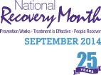
NAMI – Beaver County
& Project Recovery
presents . . .

Movie Night at NAMI
(NOTE: This movie is for adults only as it is rated R
for language and some sexual content/nudity.)

Movie begins promptly at 7:00 pm on Sept. 29th, 2014.
NAMI Beaver 1229 3rd St. Beaver, PA 15009

This event is FREE and includes popcorn and drinks. All are welcome to attend. Come and share a fun night with your friends!

