Orchard Street

NAMI

**KEY**

**= Available Parking**

**1229**

**1201**

**1211**

Corporation St.

3rd Street

Buffalo Street

**1231**

**Rezk**

**Medical**

**Supply**

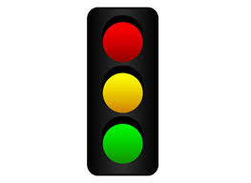

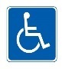

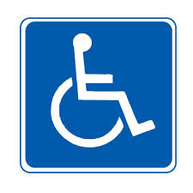

**Evening Parking Only**

**There are 2 Free Parking Spaces in the front of the NAMI-Beaver Building on 3rd Street. You will need to come up a few stairs from the front of the building.**

**2 more Free Parking Spaces are nearby in front of Rezk Medical Supply on 3rd Street.**

**Free Parking is available on both sides of Corporation Street. From here, there is a narrow alley that leads to the back of the NAMI buiding. Part of Orchard Street may be open as well. An access ramp and small set of stairs are located at the back of the building.**

3rd Street