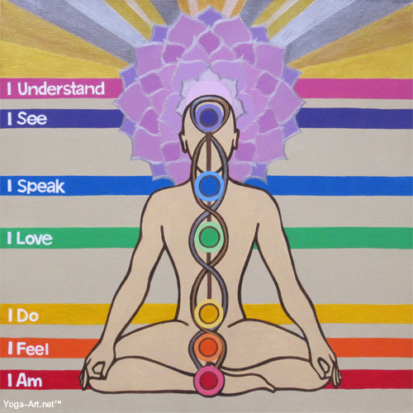

Yoga for Reducing Anxiety
A Few Reasons to Roll Out Your Mat!

Samar Eid, RN, DNP student
Dr. Janene Luther Szpak, DNP, PMHNP-BC
Robert Morris University

Anxiety disorders Overview:

In the year 2011, the World Health Organization (WHO) estimated that neuropsychiatric

conditions are the leading cause of disability worldwide, accounting for 37% of all healthy life

years lost from disease. According to the National Institute of Mental Health (NIMH), in a given

year, approximately 40 million American adults meet criteria for an anxiety disorder with

generalized anxiety disorder (GAD) affecting 6.8 million American adults, ages 18 years and

older, including twice as many women as men.

What are the current treatment Options?

The current treatment options include medication, psychotherapy, or both. Some people respond better by having Cognitive Behavioral Therapy (CBT), while others improve with antidepressants and anti-anxiety medications. Many report the combination of both being effective. Some patients have either significant symptoms or side effects to medications requiring the provider to search for further options and adjuncts to current conventional treatments.

Yoga as an alternative option?

Based on many factors including side effects of medications, cost, and sometimes treatment

resistance, many patients are turning to alternative approaches to traditional psychotherapy and

pharmacological treatments. These include the use of meditation and yoga to reduce stress and anxiety.

Some key reasons for this trend include that both yoga and meditation offer therapeutic and often spiritual benefits while avoiding side effects of medications, the stigma of treatments, as well
as, the barriers of cost and accessibility.

Yoga Research

Scientific research studies on the psychological benefits of yoga practice dates back to the early

20th century. This growing body of research reveals that the most consistent and reproducible

effects of yoga practice include:

1-stress reduction
2-emotion regulation
3-improved mood and well-being
4 improved cognitive functioning
5-enhanced respiratory function
6-improved physical flexibility, muscular strength, and neuromuscular performance.

The Harvard Mental Health letter (2009) suggests that yoga practice modulates the stress

response and that preliminary evidence shows a benefit similar to that of exercise and relaxation

techniques. At the end of a three months yoga study of women who described themselves as

“emotionally distressed”, and consequently were assigned to two 90 minute yoga classes weekly, women in the yoga group reported improvements in perceived stress, anxiety, depression,
energy, fatigue, and overall well-being. The results show 50% improved scores of depression, 30% for

anxiety as well as overall well-being scores by 65%. Complaints of headaches, back pain, and

poor sleep quality reported prior to starting yoga also resolved more in the yoga group than in

the control group. All participants had history of emotional distress for at least half of the

previous 90 days. Women in the control group were asked not to exercise and to maintain normal

activities during the study period. In another study, long- term yoga practitioners have reported lower

mental disturbances, tension, anxiety, anger, hostility, and fatigue scores, in comparison to non-experienced participants. In our busy and sometimes overwhelming world it is crucial to find moments of silence, calm and inner piece. We don’t have to be anxious to benefit from yoga. Roll out your mat and find yourself a down dog or two!
References

American Psychiatric Association. (2013). Diagnostic And Statistical Manual of Mental
Disorders (5th ed.) (pp. 222). Arlington, VA: American Psychiatric Publishing.

Balasubramaniam, M., Doraiswamy, M., & Telles, C. (2012). Yoga on our minds: A systematic review of yoga for neuropsychiatric disorders. Frontiers in Psychiatry, 3,117.

Berger, C., Chen, K., Dachman, L., Forde, D., lejuez, C.W., Magidson, J., & Manheimer, E. (2012). Meditative therapies for reducing anxiety: a systematic review and meta-analysis
of randomized controlled trials. Depression and Anxiety, 29, 545–562.

Berk, M., Camfield, D.A., Jacka, F.M., Mischoulon, D., Moylan, S., Pase, P., Sarris, J., & Schweitze, I. (2012). Complementary medicine, exercise, meditation, diet, and lifestyle modification for anxiety disorders: A review of current evidence. Evidence-based Complementary and Alternative Medicine, 2012, 1-20.

Ednefield, M., & Saeed, A. (2012). An update on mindfulness meditation as a self-help treamtment for anxiety and depression. Psychology Research and Behavior Management, 5,131-141.

Harvard Mental Health Letter. (2009). Yoga for anxiety and depression. 25 (10), 4-5.

Hiramoto, T., Kubo, C. , Sudo, N., & Yoshihara, K. (2011). Profile of mood states and stress related biochemical indices in long-term yoga practitioners. BioPsychoSocial Medicine, 5, 6.

Keshavan, M.S., Rao, N.P., & Rao, T.S.S. (2013). Yoga and mental health promising road ahead, but proceed with caution. Indian Journal of Psychiatry, 55, 329-331.

Khalsa, S.B.S. (2013). Yoga for psychiatry and mental health: an ancient practice with modern
Relevance. Indian Journal of Psychiatry, 55, 334-336.

Methorst, G., Muris, P., Van der Heiden, C., &Van der Molen, H. (2011). Generalized Anxiety Disorder: Clinical presentation, diagnostic features, and guidelines for clinical practice. Journal of Clinical Psychology, 67, 58-73.

National Institute of Mental Health. (2013). Generalized Anxiety Disorders. Retrieved from:
http://www.nimh.nih.gov/health/topics/Generalized-anxiety-disorder.gad/index.shtml

